Hands-on 1:
Spring REST using Spring Boot 3:

Exercise 1:
Create a Spring Web Project using Maven

Spring Initializr Configuration :

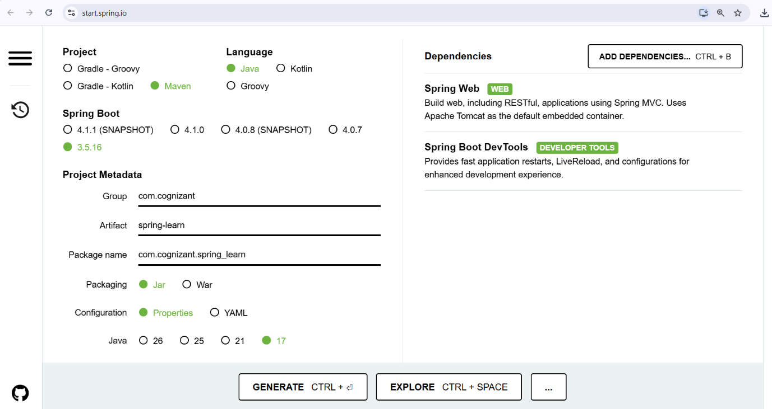

Imported Project in STS :
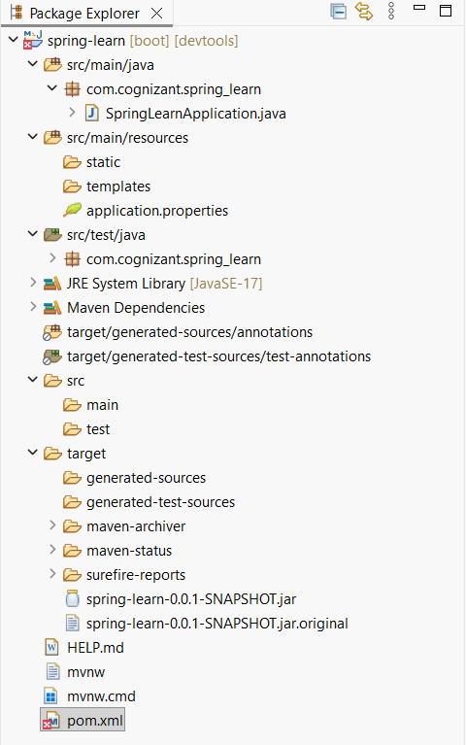

File name : SpringLearnApplication.java
package com.cognizant.spring_learn;

import org.slf4j.Logger;
import org.slf4j.LoggerFactory;
import org.springframework.boot.SpringApplication;
import org.springframework.boot.autoconfigure.SpringBootApplication;

@SpringBootApplication
public class SpringLearnApplication {

private static final Logger LOGGER =
LoggerFactory.getLogger(SpringLearnApplication.class);

public static void main(String[] args) {

LOGGER.info("START");

SpringApplication.run(SpringLearnApplication.class, args);

LOGGER.info("END");
}
}

Output :
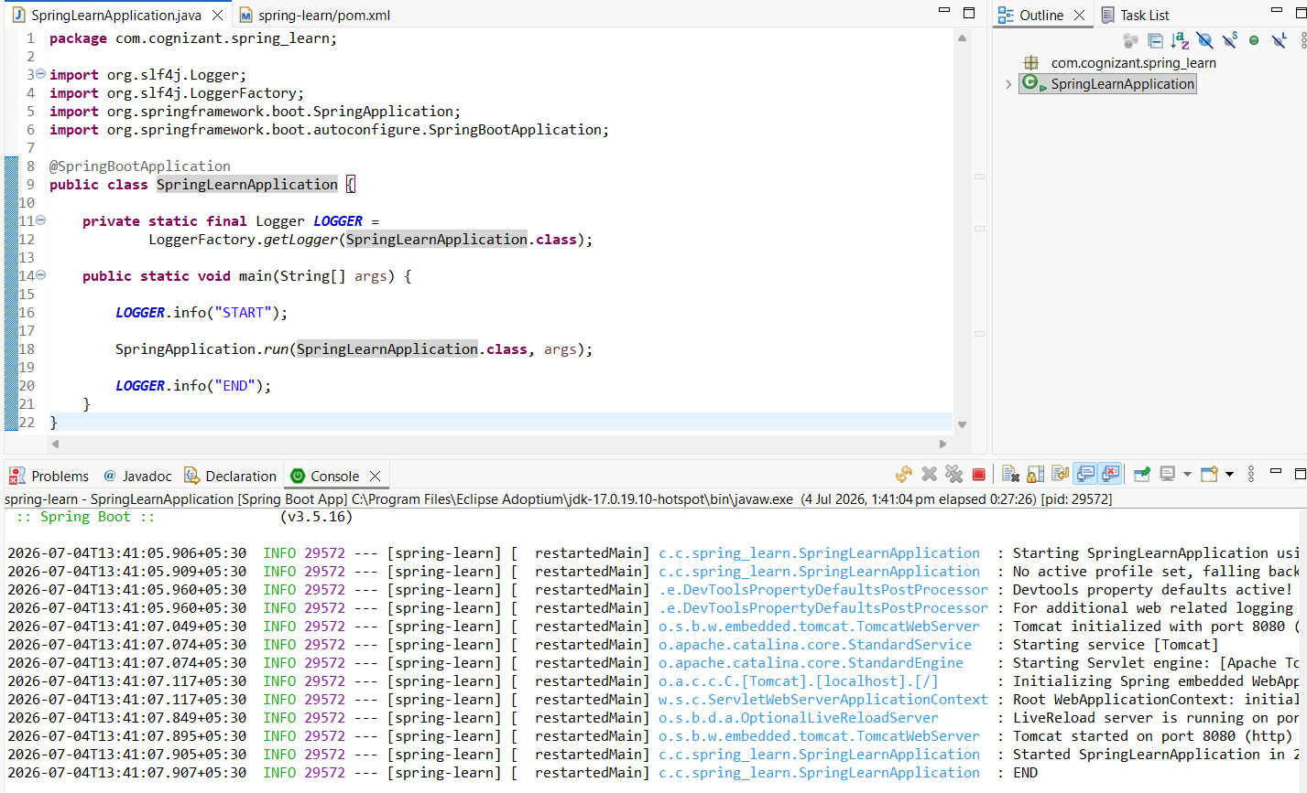

Pom.xml :
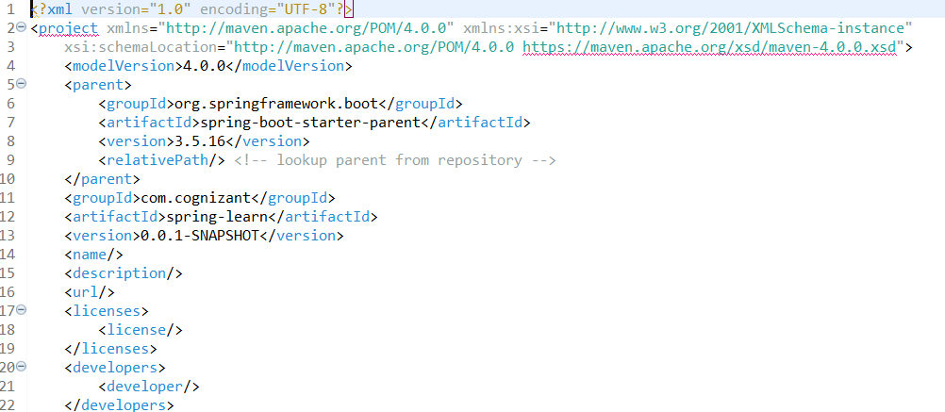

Dependeny Hierarchy :
